Sign Up
- Go to www.qrfastpass.com
- Click on Sign up
- Move to End of Licensee agreement and accept
- Click on Continue
- Fill in the section Labeled Subscriber Information (This is the Entity getting billed)
- Fill in the Physical Location ( The location of the property being protected)
- Create a gate keeper password which will be used by the security guard.
- Fill in the Gate Access Information ( Name of gate and phone number)
- Click on Continue
- Shows your recap page with your password and email
- This complete the sign up

Modify Subscriber Information

- Go to www.qrfastpass.com
- Log in using your email and password
- The following screen should appear with your subscriber name in the center

- In the top left corner is a pull down menu labeled Maintenance
- Pull down the maintenance tab and select Modify Profile
- Make the Necessary correction and then click on Continue

Issue Tenant Invitation to Register

- go to www.qrfastpass.com
- Log in using your email and password
- The following screen should appear with your subscriber name in the center

- In the top left corner is a pull down menu labeled Maintenance
- Pull down the maintenance tab and select Issue Signup Code
- The screen should appear as shown below.

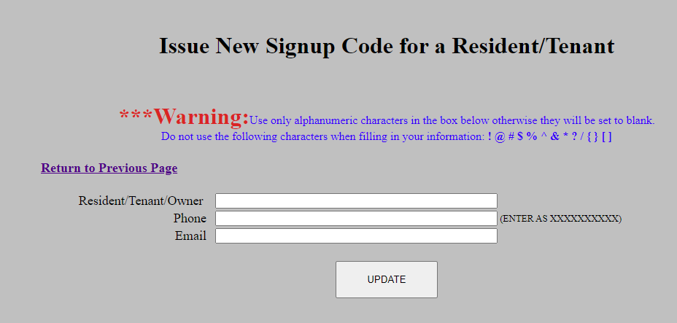

- Fill in the Resident/Owner, Phone Number, and Email
- Click on Update
- A new signup code will be emailed to this Resident/Owner so they can register.

How to start Scanning Codes

Method A

- Go to www.qrfastpass.com
- Log in using your email and password
- The following screen should appear with your Subscriber name in the center

- Under the heading tab called Security Guard is a sub heading called start scan location.
- Select the gate that the guard is working at and click continue
- The system is ready to accept scans as shown below.

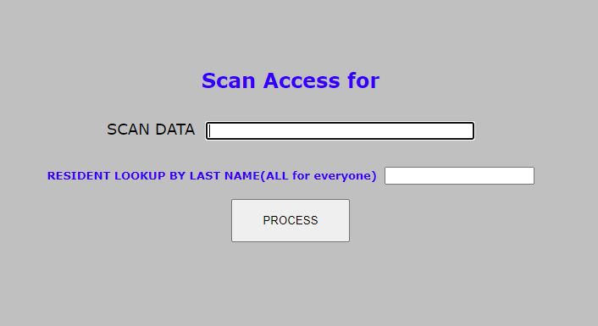

- The screen will turn green or red depending on the status of the QR code.
- Just hit process and the screen is ready for the next scan.

Method B
- Go to www.qrfastpass.com
- The security Guard logs in using his own password with the subscriber’s email
- Select the gate that the guard is working at and click continue
- The system is ready to accept scans as shown above.

